**Digital NUTURE 4.0 – DEEP SKILLING STAGE**

**Hands on 1**

**Spring Data JPA - Quick Example**   
  
**Software Pre-requisites**

* MySQL Server 8.0
* MySQL Workbench 8
* Eclipse IDE for Enterprise Java Developers 2019-03 R
* Maven 3.6.2

**Create a Eclipse Project using Spring Initializr**

* Go to <https://start.spring.io/>
* Change Group as “com.cognizant”
* Change Artifact Id as “orm-learn”
* In Options > Description enter "Demo project for Spring Data JPA and Hibernate"
* Click on menu and select "Spring Boot DevTools", "Spring Data JPA" and "MySQL Driver"
* Click Generate and download the project as zip
* Extract the zip in root folder to Eclipse Workspace
* Import the project in Eclipse "File > Import > Maven > Existing Maven Projects > Click Browse and select extracted folder > Finish"
* Create a new schema "ormlearn" in MySQL database. Execute the following commands to open MySQL client and create schema.

> mysql -u root -p

mysql> create schema ormlearn;

* In orm-learn Eclipse project, open src/main/resources/application.properties and include the below database and log configuration.

# Spring Framework and application log

logging.level.org.springframework=info

logging.level.com.cognizant=debug

# Hibernate logs for displaying executed SQL, input and output

logging.level.org.hibernate.SQL=trace

logging.level.org.hibernate.type.descriptor.sql=trace

# Log pattern

logging.pattern.console=%d{dd-MM-yy} %d{HH:mm:ss.SSS} %-20.20thread %5p %-25.25logger{25} %25M %4L %m%n

# Database configuration

spring.datasource.driver-class-name=com.mysql.cj.jdbc.Driver

spring.datasource.url=jdbc:mysql://localhost:3306/ormlearn

spring.datasource.username=root

spring.datasource.password=root

# Hibernate configuration

spring.jpa.hibernate.ddl-auto=validate

spring.jpa.properties.hibernate.dialect=org.hibernate.dialect.MySQL5Dialect

* Build the project using ‘mvn clean package -Dhttp.proxyHost=proxy.cognizant.com -Dhttp.proxyPort=6050 -Dhttps.proxyHost=proxy.cognizant.com -Dhttps.proxyPort=6050 -Dhttp.proxyUser=123456’ command in command line
* Include logs for verifying if main() method is called.

import org.slf4j.Logger;

import org.slf4j.LoggerFactory;

private static final Logger LOGGER = LoggerFactory.getLogger(OrmLearnApplication.class);

public static void main(String[] args) {

SpringApplication.run(OrmLearnApplication.class, args);

  LOGGER.info("Inside main");

}

* Execute the OrmLearnApplication and check in log if main method is called.

SME to walk through the following aspects related to the project created:

1. src/main/java - Folder with application code
2. src/main/resources - Folder for application configuration
3. src/test/java - Folder with code for testing the application
4. OrmLearnApplication.java - Walkthrough the main() method.
5. Purpose of @SpringBootApplication annotation
6. pom.xml
   1. Walkthrough all the configuration defined in XML file
   2. Open 'Dependency Hierarchy' and show the dependency tree.

**Country table creation**

* Create a new table country with columns for code and name. For sample, let us insert one country with values 'IN' and 'India' in this table.

create table country(co_code varchar(2) primary key, co_name varchar(50));

* Insert couple of records into the table

insert into country values ('IN', 'India');

insert into country values ('US', 'United States of America');

**Persistence Class - com.cognizant.orm-learn.model.Country**

* Open Eclipse with orm-learn project
* Create new package com.cognizant.orm-learn.model
* Create Country.java, then generate getters, setters and toString() methods.
* Include @Entity and @Table at class level
* Include @Column annotations in each getter method specifying the column name.

import javax.persistence.Column;

import javax.persistence.Entity;

import javax.persistence.Id;

import javax.persistence.Table;

@Entity

@Table(name="country")

public class Country {

  @Id

    @Column(name="code")

    private String code;

    @Column(name="name")

    private String name;

// getters and setters

  // toString()

}

*Notes:*

* @Entity is an indicator to Spring Data JPA that it is an entity class for the application
* @Table helps in defining the mapping database table
* @Id helps is defining the primary key
* @Column helps in defining the mapping table column

**Repository Class - com.cognizant.orm-learn.CountryRepository**

* Create new package com.cognizant.orm-learn.repository
* Create new interface named CountryRepository that extends JpaRepository<Country, String>
* Define @Repository annotation at class level

import org.springframework.data.jpa.repository.JpaRepository;

import org.springframework.stereotype.Repository;

import com.cognizant.ormlearn.model.Country;

@Repository

public interface CountryRepository extends JpaRepository<Country, String> {

}

**Service Class - com.cognizant.orm-learn.service.CountryService**

* Create new package com.cognizant.orm-learn.service
* Create new class CountryService
* Include @Service annotation at class level
* Autowire CountryRepository in CountryService
* Include new method getAllCountries() method that returns a list of countries.
* Include @Transactional annotation for this method
* In getAllCountries() method invoke countryRepository.findAll() method and return the result

**Testing in OrmLearnApplication.java**

* Include a static reference to CountryService in OrmLearnApplication class

private static CountryService countryService;

* Define a test method to get all countries from service.

    private static void testGetAllCountries() {

        LOGGER.info("Start");

        List<Country> countries = countryService.getAllCountries();

        LOGGER.debug("countries={}", countries);

        LOGGER.info("End");

    }

* Modify SpringApplication.run() invocation to set the application context and the CountryService reference from the application context.

        ApplicationContext context = SpringApplication.run(OrmLearnApplication.class, args);

        countryService = context.getBean(CountryService.class);

        testGetAllCountries();

* Execute main method to check if data from ormlearn database is retrieved.

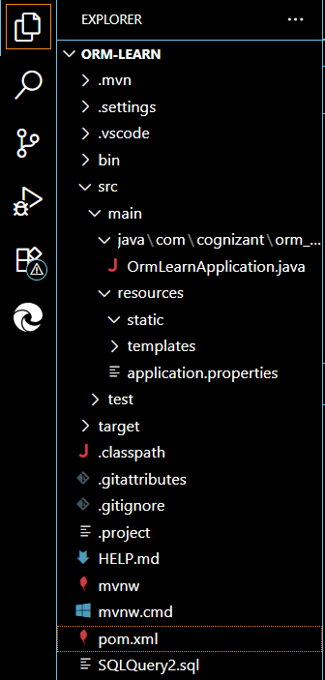

**OrmLearnApplication.java**

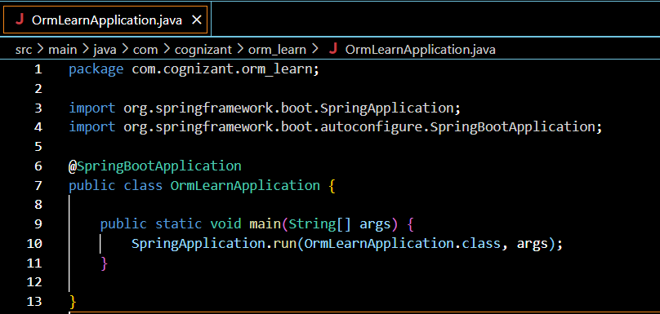

**applicationProperties:**

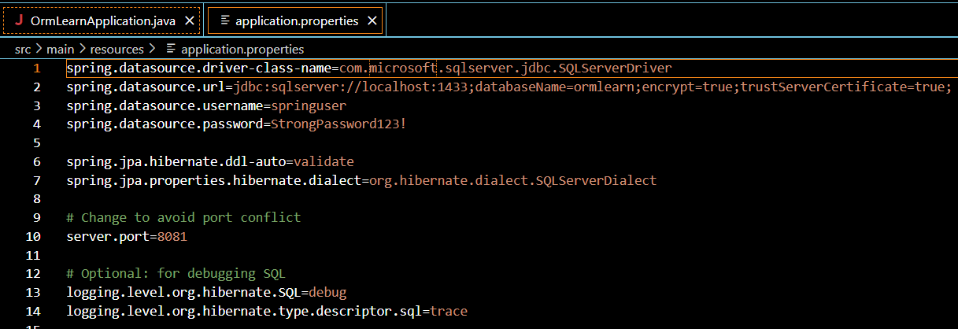

**pox.xml**

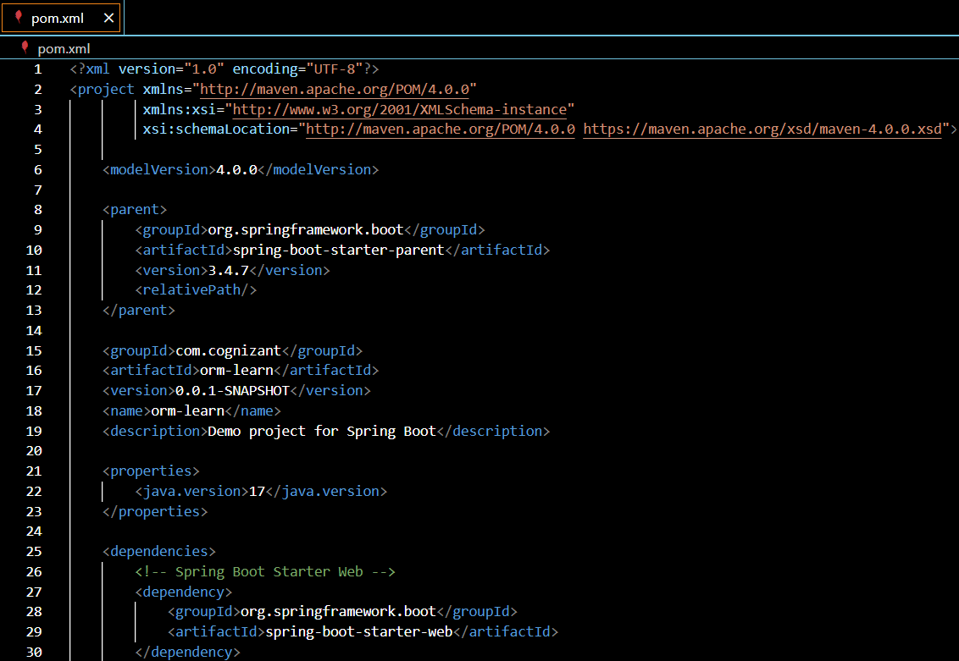

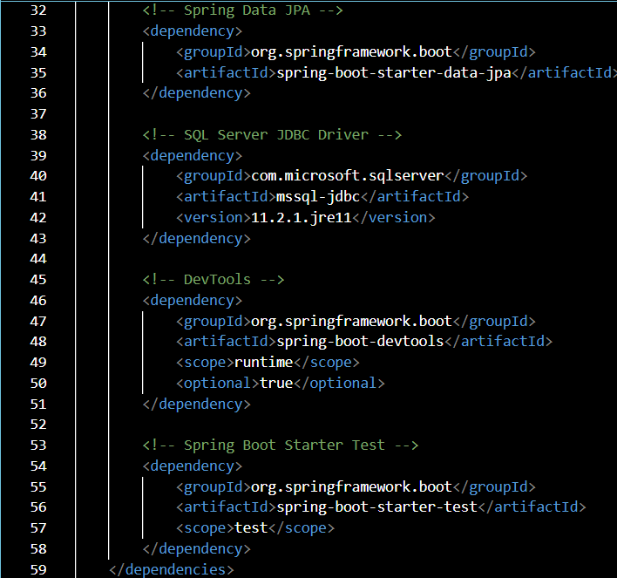 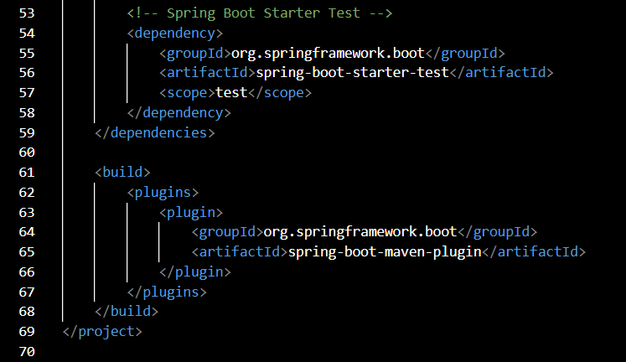

**Output**

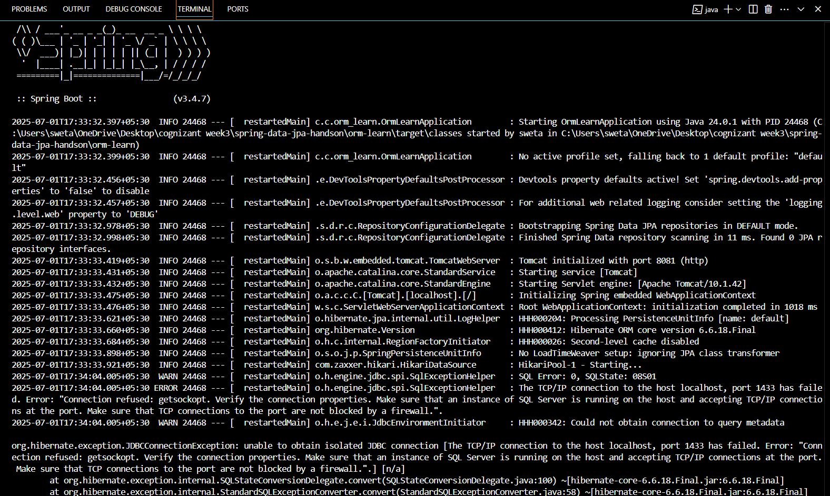 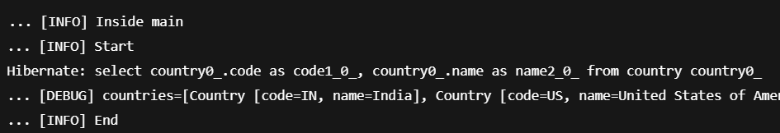

**Hands on 4**

**Difference between JPA, Hibernate and Spring Data JPA**   
  
Java Persistence API (JPA)

* JSR 338 Specification for persisting, reading and managing data from Java objects
* Does not contain concrete implementation of the specification
* Hibernate is one of the implementation of JPA

Hibernate

* ORM Tool that implements JPA

Spring Data JPA

* Does not have JPA implementation, but reduces boiler plate code
* This is another level of abstraction over JPA implementation provider like Hibernate
* Manages transactions

**Refer code snippets below on how the code compares between Hibernate and Spring Data JPA  
Hibernate**

   /* Method to CREATE an employee in the database */

   public Integer addEmployee(Employee employee){

      Session session = factory.openSession();

      Transaction tx = null;

      Integer employeeID = null;

      try {

         tx = session.beginTransaction();

         employeeID = (Integer) session.save(employee);

         tx.commit();

      } catch (HibernateException e) {

         if (tx != null) tx.rollback();

         e.printStackTrace();

      } finally {

         session.close();

      }

      return employeeID;

   }

**Spring Data JPA**  
EmployeeRespository.java

public interface EmployeeRepository extends JpaRepository<Employee, Integer> {

}

EmployeeService.java

@Autowire

  private EmployeeRepository employeeRepository;

@Transactional

public void addEmployee(Employee employee) {

  employeeRepository.save(employee);

  }

​​​​​​​   
  
**Reference Links:**   
<https://dzone.com/articles/what-is-the-difference-between-hibernate-and-sprin-1>   
<https://www.javaworld.com/article/3379043/what-is-jpa-introduction-to-the-java-persistence-api.html>

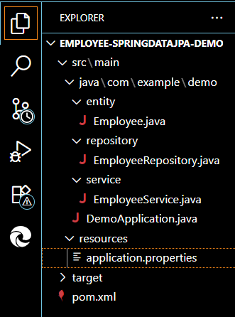

**Employee.java:**

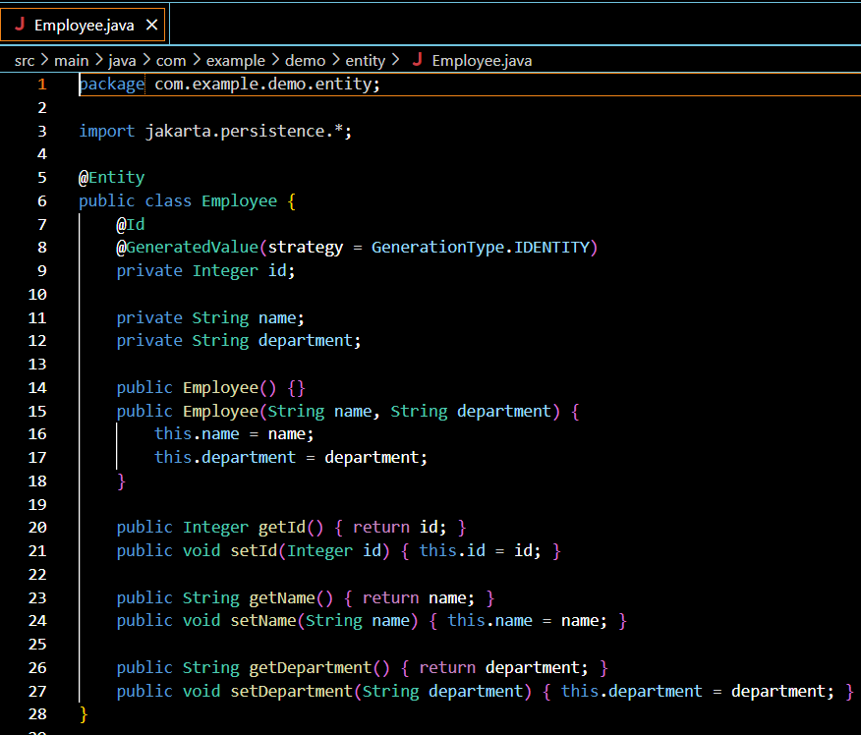

**EmployeeRepository.java**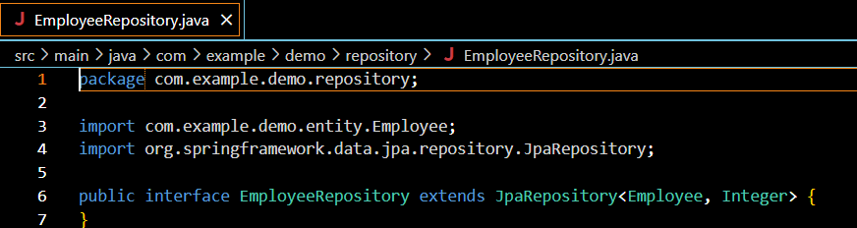

**EmployeeService.java**

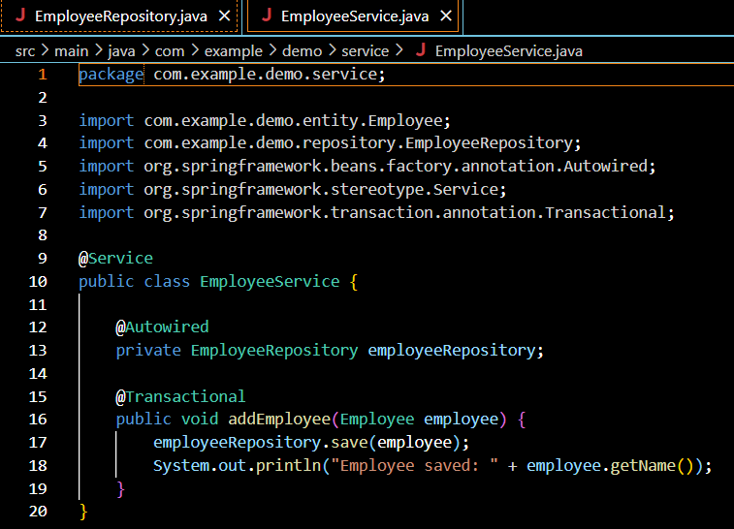

**DemoApplication.java**

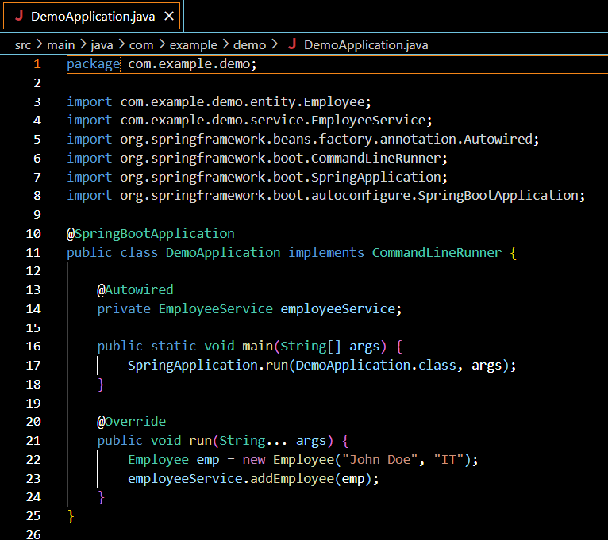



**applicationProperties:**

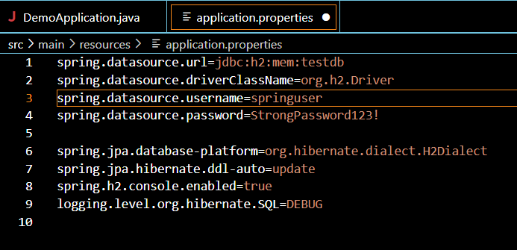

**Pom.xml**

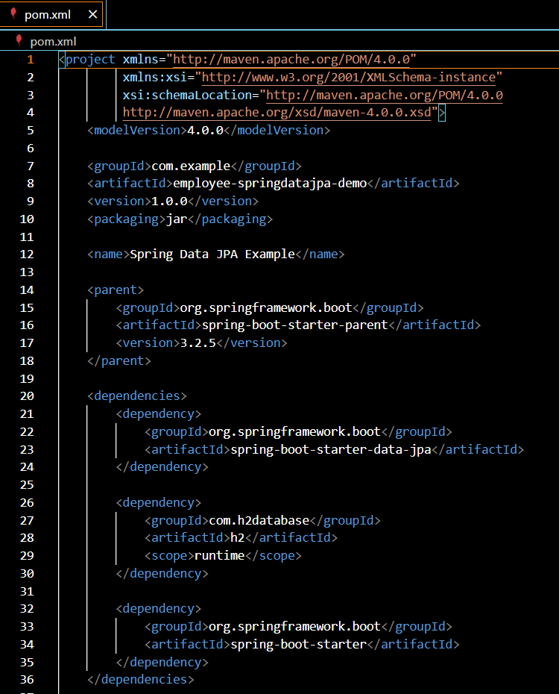

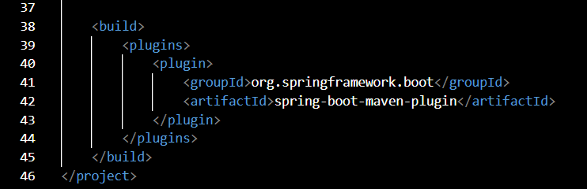

**Output:**

